Lagged cross-correlation: EURUSD and USDCAD
Method 12 / daily log returns / K_max=10 / Alpari D1 full available history

Study setup
Logical pair: EURUSD , USDCAD
Broker symbols: EURUSD_i , USDCAD_i
Snapshot: 2026-11-03_majors_alpari_D1
Timeframe: D1
Matched return window: 1999-01-05 to 2026-11-02 (UTC bar dates)
Matched return count n: 7188
Dropped unfinished last bar dated 2026-11-03 UTC after a tick-volume check against the prior complete day.
Lag definition: rho_X->Y(k) = Corr(x_t, y_{t+k}) on matched D1 bars
K_max = 10; headline lag k = 1 (both directions)
Complete matched rows (Excel): EURUSD-USDCAD_Lagged_D1.xlsx
Complete matched rows (HTML table): EURUSD-USDCAD_Lagged_D1_data.html

Method carried forward
Lagged cross-correlation measures Pearson correlation between matched daily log returns of close, ln(close_t / close_t-1), after shifting one series forward by k bars on the matched panel. Quotes are not inverted. rho_{X->Y}(k) = Corr(x_t, y_{t+k}) with n_k = n - k. K_max = 10 is fixed before estimation. The headline is the pre-specified lag k = 1 in both directions. k = 0 is the same-bar side check. The lag inside 1..10 with the largest absolute rho is stored as a descriptive column only; it is not a selected result. This is a linear screen, not proof of forecast edge, economic cause, or a trading signal.

Results (headline k=1)
rho_EURUSD->USDCAD(1): 0.040711 (n=7187)
95% Fisher interval EURUSD->USDCAD: [0.017608, 0.063771]
rho_USDCAD->EURUSD(1): -0.004659 (n=7187)
95% Fisher interval USDCAD->EURUSD: [-0.027776, 0.018463]
Same-bar rho(k=0): -0.456626
Largest |rho| among k=1..10 (descriptive only, not selected): EURUSD->USDCAD k=1 rho=0.040711; USDCAD->EURUSD k=9 rho=0.042495

CCF table
k | rho_EURUSD_to_USDCAD | n_EURUSD_to_USDCAD | rho_USDCAD_to_EURUSD | n_USDCAD_to_EURUSD
0 | -0.45662552 | 7188 | -0.45662552 | 7188
1 | 0.040711 | 7187 | -0.00465902 | 7187
2 | -0.01739868 | 7186 | -0.00307264 | 7186
3 | 0.01802204 | 7185 | -0.0034993 | 7185
4 | -0.02713032 | 7184 | -0.01734473 | 7184
5 | 0.00930293 | 7183 | -0.00061003 | 7183
6 | 0.00865972 | 7182 | 0.01773361 | 7182
7 | -6.845e-05 | 7181 | 0.00657127 | 7181
8 | -0.01004397 | 7180 | -0.0417765 | 7180
9 | 0.0173752 | 7179 | 0.0424955 | 7179
10 | 0.00994625 | 7178 | -0.00359109 | 7178

Conclusion
At the pre-specified lag k=1 for EURUSD and USDCAD, rho_{EURUSD->USDCAD}(1) = 0.0407 (n=7187) and rho_{USDCAD->EURUSD}(1) = -0.0047 (n=7187). Same-bar rho(k=0) = -0.4566. Largest |rho| among k=1..10 is descriptive only: EURUSD->USDCAD at k=1 (0.0407); USDCAD->EURUSD at k=9 (0.0425). This is a linear screen, not forecast proof or a trading signal.

Charts
Daily closes

Daily log returns

CCF both directions k=0..10
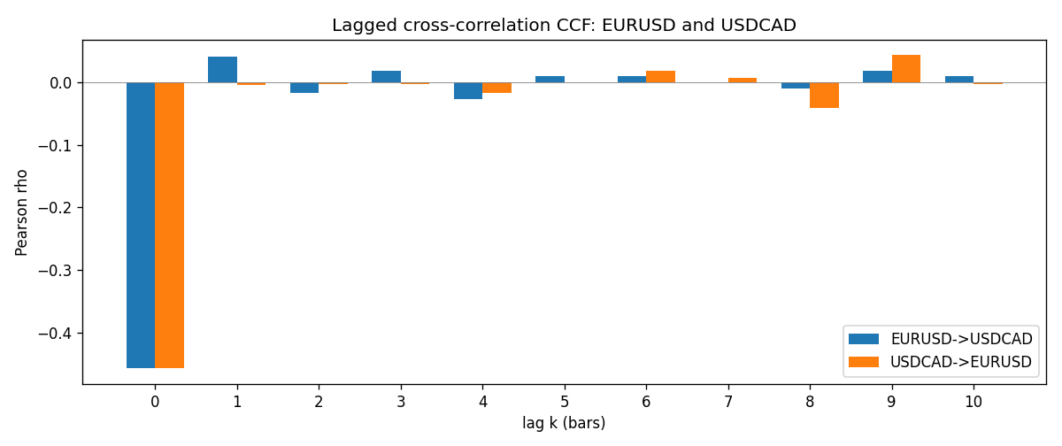

Data report
Every matched row is stored in the sibling Excel workbook named EURUSD-USDCAD_Lagged_D1.xlsx (sheet matched_rows). The CCF sheet holds rho(k) for k=0..10. Embedding all rows as a Word table is impractical; the Word file holds column summaries and the first and last 15 rows.
Columns: time, EURUSD_open, USDCAD_open, EURUSD_high, USDCAD_high, EURUSD_low, USDCAD_low, EURUSD_close, USDCAD_close, EURUSD_tick_volume, USDCAD_tick_volume, EURUSD_spread, USDCAD_spread, EURUSD_real_volume, USDCAD_real_volume, EURUSD_log_return, USDCAD_log_return
Column summaries (matched calculation rows)
column | count | mean | std | min | 25% | 50% | 75% | max
EURUSD_open | 7188 | 1.1814345 | 0.15078289 | 0.8272 | 1.086195 | 1.16617 | 1.2939425 | 1.5995
USDCAD_open | 7188 | 1.2667783 | 0.16890181 | 0.9168 | 1.1183975 | 1.298465 | 1.37211 | 1.6183
EURUSD_high | 7188 | 1.1865652 | 0.15138546 | 0.8326 | 1.0902775 | 1.17128 | 1.2993025 | 1.6038
USDCAD_high | 7188 | 1.2716763 | 0.16885945 | 0.9336 | 1.12285 | 1.30387 | 1.37649 | 1.619
EURUSD_low | 7188 | 1.1764236 | 0.15010221 | 0.8227 | 1.0820675 | 1.16257 | 1.2883725 | 1.5865
USDCAD_low | 7188 | 1.26222 | 0.16893673 | 0.9056 | 1.114065 | 1.293535 | 1.367805 | 1.6102
EURUSD_close | 7188 | 1.181473 | 0.1507571 | 0.8267 | 1.0860725 | 1.166175 | 1.2939575 | 1.5997
USDCAD_close | 7188 | 1.2667932 | 0.16887388 | 0.916 | 1.118295 | 1.29844 | 1.372365 | 1.6137
EURUSD_tick_volume | 7188 | 103177.84 | 173518.96 | 218 | 9407.75 | 52764 | 99553.25 | 1471626
USDCAD_tick_volume | 7188 | 81016.727 | 147303.02 | 37 | 5545 | 40941.5 | 71627 | 1410818
EURUSD_spread | 7188 | 19.349471 | 16.556644 | 0 | 8 | 12 | 30 | 50
USDCAD_spread | 7188 | 23.444073 | 18.266035 | 0 | 9 | 17 | 40 | 60
EURUSD_real_volume | 7188 | 4.031926e+10 | 1.6689501e+11 | 0 | 0 | 0 | 0 | 3.6149665e+12
USDCAD_real_volume | 7188 | 1.8376704e+10 | 9.6688094e+10 | 0 | 0 | 0 | 0 | 2.5751613e+12
EURUSD_log_return | 7188 | -7.59e-06 | 0.00580128 | -0.03123819 | -0.0032472 | 0 | 0.00325412 | 0.03433183
USDCAD_log_return | 7188 | -1.518e-05 | 0.00514306 | -0.03859748 | -0.00283637 | 4.741e-05 | 0.00272353 | 0.03436319
First 15 matched rows (selected columns)
time | EURUSD_close | USDCAD_close | EURUSD_log_return | USDCAD_log_return
1999-01-05 | 1.1758 | 1.5123 | -0.0048360507 | -0.010131666
1999-01-06 | 1.1623 | 1.5118 | -0.011547966 | -0.0003306769
1999-01-07 | 1.1712 | 1.5141 | 0.0076280636 | 0.0015202092
1999-01-08 | 1.1585 | 1.511 | -0.010902799 | -0.0020495197
1999-01-11 | 1.1503 | 1.5057 | -0.007103287 | -0.0035137769
1999-01-12 | 1.1555 | 1.5157 | 0.0045103728 | 0.0066194721
1999-01-13 | 1.1681 | 1.5226 | 0.010845346 | 0.0045420214
1999-01-14 | 1.1681 | 1.5332 | 0 | 0.0069376546
1999-01-15 | 1.1563 | 1.5245 | -0.010153245 | -0.0056905671
1999-01-18 | 1.1605 | 1.526 | 0.0036256946 | 0.00098344542
1999-01-19 | 1.1603 | 1.5302 | -0.00017235436 | 0.002748513
1999-01-20 | 1.1566 | 1.5211 | -0.0031939256 | -0.0059646885
1999-01-21 | 1.1601 | 1.5146 | 0.0030215416 | -0.0042823796
1999-01-22 | 1.1587 | 1.5184 | -0.0012075213 | 0.0025057712
1999-01-25 | 1.1552 | 1.5197 | -0.0030251979 | 0.00085579808
Last 15 matched rows (selected columns)
time | EURUSD_close | USDCAD_close | EURUSD_log_return | USDCAD_log_return
2026-10-13 | 1.11965 | 1.4214 | 0.0037402957 | -0.0046395653
2026-10-14 | 1.11545 | 1.42356 | -0.0037582255 | 0.0015184751
2026-10-15 | 1.12172 | 1.41843 | 0.0056053107 | -0.0036101503
2026-10-16 | 1.12371 | 1.41357 | 0.0017724895 | -0.0034322068
2026-10-19 | 1.12086 | 1.41091 | -0.0025394633 | -0.0018835331
2026-10-20 | 1.12354 | 1.40569 | 0.0023881672 | -0.0037066008
2026-10-21 | 1.12318 | 1.4045 | -0.00032046717 | -0.00084691787
2026-10-22 | 1.12139 | 1.40081 | -0.0015949606 | -0.0026307268
2026-10-23 | 1.11989 | 1.40085 | -0.001338521 | 2.85545e-05
2026-10-26 | 1.11735 | 1.40093 | -0.0022706559 | 5.7106554e-05
2026-10-27 | 1.11272 | 1.40449 | -0.004152342 | 0.0025379458
2026-10-28 | 1.1152 | 1.39911 | 0.0022262927 | -0.0038379274
2026-10-29 | 1.11772 | 1.39895 | 0.0022571351 | -0.00011436495
2026-10-30 | 1.11644 | 1.39751 | -0.0011458446 | -0.0010298736
2026-11-02 | 1.11881 | 1.39837 | 0.002120569 | 0.00061519094

